Dance Venues

12:50 - The Grange

12:10 - Old Cottage Tavern

16:20 - Town Hall
14:20: The Alfred

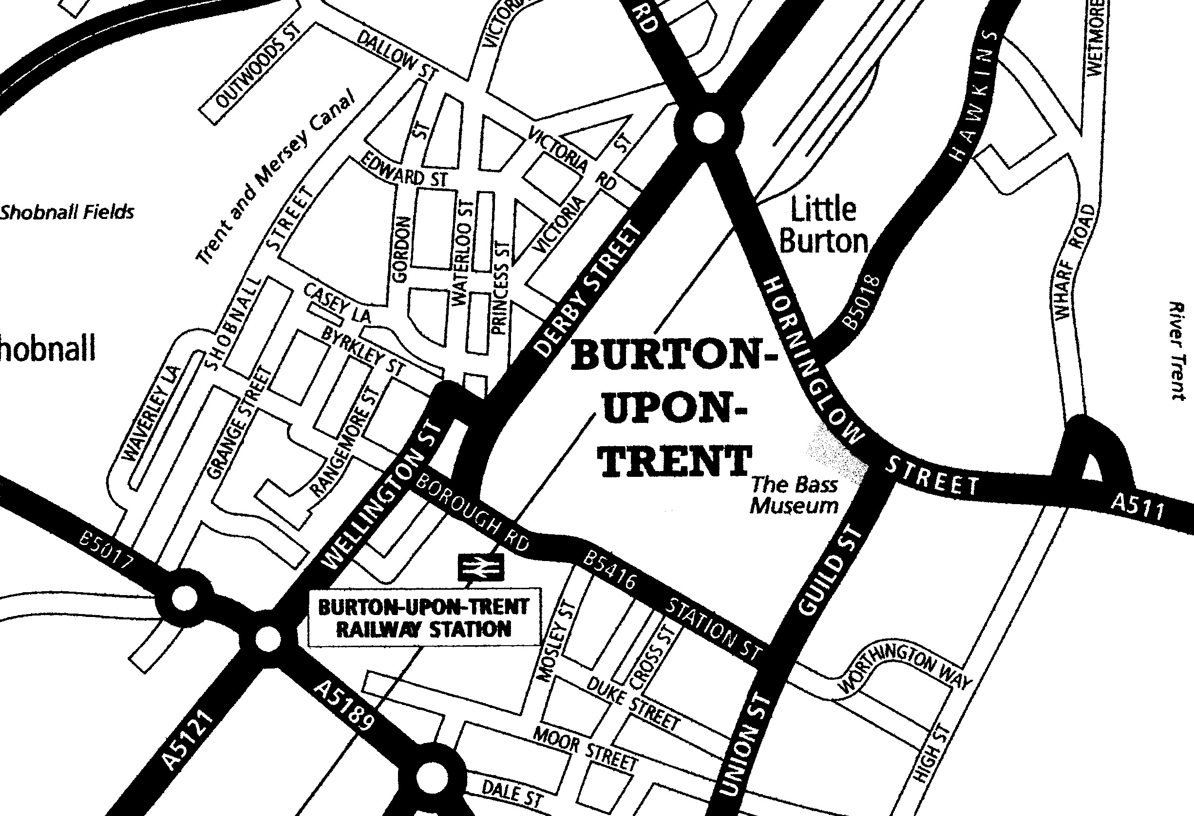
Roebuck Inn
Travelodge

15:40 - Coopers Tavern
15:00 - Devonshire Arms

