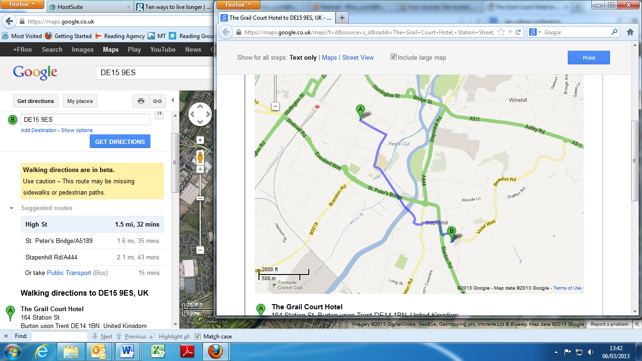

|  |  |  |
| --- | --- | --- |
| Show for all steps: | [Text only](javascript:void(0)) | [Maps](javascript:void(0)) | [Street View](javascript:void(0)) | Include large map |

Roll over the directions to customise each step.

|  |  |
| --- | --- |
|  | Directions to DE15 9ES, UK  **1.5 mi** – about **32 mins** |
| |  | | --- | |  | |
|  |
| **Walking directions are in beta.** Use caution – This route may be missing sidewalks or pedestrian paths. | |

Loading...

|  |  |  |  |
| --- | --- | --- | --- |
|  | The Grail Court Hotel  164 Station St, Burton upon Trent DE14 1BN, United Kingdom‎ | |  |
|  | 1. | Head **southeast** on **Station St/B5416** toward **Guild St/B5018**  Continue to follow Station St  About 4 mins | | | go 0.2 mi  total 0.2 mi |

|  |  |  |  |
| --- | --- | --- | --- |
|  | 2. | Turn right onto **High St**  About 3 mins | go 0.1 mi  total 0.4 mi |
|  | 3. | At the roundabout, take the **2nd** exit onto **Lichfield St**  About 1 min | | | go 407 ft  total 0.4 mi |

|  |  |  |  |  |  |
| --- | --- | --- | --- | --- | --- |
|  | 4. | Continue onto **Abbey St**  About 1 min | | go 272 ft  total 0.5 mi | |
|  | 5. | Turn left onto **Fleet St**  About 9 mins | go 0.5 mi  total 1.0 mi | |

|  |  |  |  |  |  |
| --- | --- | --- | --- | --- | --- |
|  | 6. | Continue onto **The Dingle**  About 2 mins | | go 449 ft  total 1.0 mi | |
|  | 7. | Turn left onto **Ferry St**  About 1 min | go 358 ft  total 1.1 mi | |

|  |  |  |  |  |
| --- | --- | --- | --- | --- |
|  | 8. | Turn left onto **Main St** | go 62 ft  total 1.1 mi | |
|  | 9. | Turn right onto **Holly St**  About 3 mins | | go 0.1 mi  total 1.2 mi | |

|  |  |  |  |
| --- | --- | --- | --- |
|  | 10. | Turn right onto **Stanton Rd/A444**  About 3 mins | go 0.1 mi  total 1.4 mi |
|  | 11. | At the roundabout, take the **1st** exit onto **Violet Way**  About 3 mins | | | go 0.1 mi  total 1.5 mi |

|  |  |  |  |
| --- | --- | --- | --- |
|  | 12. | Turn right | go 151 ft  total 1.5 mi |
|  | 13. | Turn left  Destination will be on the right | | | go 213 ft  total 1.5 mi |

|  |  |  |
| --- | --- | --- |
|  | DE15 9ES, UK‎ |  |