Appendix A – Summary of Action Points

# Actions from 2017 AGM

Plan for if sword breaks (official plan) – Not done. Discussed during 2018 AGM

Tommying practice - done

Tumbling practice (including forward tumbles) - not done (aim to do 19/11/18)

Day of Dance - not done, discussed during 2018 AGM

Musician – done (we now have Martin)

Beverley – didn’t go, but is now cancelled going forward

Edinburgh Fringe – got invited to other things, postpone – could be 2020 or so?

Bromyard - hell yeah, we did

Tightening up jubilee - done

Random figure calling practice – not done

Buzz and tat – not really done, but was that essential?

Hoodies – done

Photos – kind of got some from Sidmouth

# Actions from 2018 EGM

LW to send hoody / t-shirt costs round – Done!

TR to communicate with Thrales about where we are crawling to avoid clashes – Done??

Crawl organisers to discuss pubs etc. – Done

Hard drive for photos... - Not done

Explore other Westerhope figures – Not done

Chorus Dance – Not done

Doodle poll for extra Sidmouth practices (HN) – Done

Ask Nikki if she would be happy to play when MC/PD can't make it – Done

EW to teach the simple clog dance – Done

Potential pub practice venues – Not found anywhere, but have looked

Beginners Guide / welcome pack, Sue shared her thing – discussed at 2018 AGM, Done

FD and BS to review Zone 9-ers – done

BS ask for extra feedback on The Ship dance – done

LW to do a doodle for Trampolining – not done

Paul - drunken historical recital at Christmas party – not done, but haven’t had a Christmas party yet!

DART - Candyrapper sort of invited us at some point. would put us up so only need to worry about flights. One or two could judge, but whole team better. Sallyport going in 2019 – Discussed at 2018 AGM

Buddied up new crawl organisers, well done all! – Done

Appendix B – Officer Reports

# Foreperson

It goes without saying that we have had a great year and I thank each and every one of you for your hard work which made it possible.

We put in a lot of intensive work in the run up to DERT, which the marks stood for themselves on. We did excellent dancing in both the main and the trad, but we also took along a new tommy, and had a second musician. All in all, we clearly made a huge impact We came third overall, which is excellent, but we also had so many people saying we were their favourite team to watch, and again commenting on how much we’ve improved.

Off the back of DERT we were invited to Sidmouth, Broadstairs and Bromyard as well as a host of smaller events. By then working *incredibly* hard at Sidmouth we’ve continued to make an excellent impression, and I firmly believe we’ve been invited to Whitby and Warwick because of it. If you look back at AGM minutes over the years it isn’t that long ago that we simply didn’t know how to break out into this recognition, so it’s amazing that we’ve got there and are getting the invites accordingly.

On a team note we’ve continued to learn – people know more positions and more dances, putting us in a stronger position at each dance out for performing more of a variety. The fact that we can happily perform the three dances, and the clog is brilliant and very freeing, gone are the days of only having one dance!

We’ve also run a workshop at a festival. Bromyard wasn’t meant to be massive, but we had as many sets as we did people and managed just fine. This is great and means we can move forward with confidence!

On a general note the team has continued to grow, particularly in the last few months, which is great! I know it can make practice a little chop and change, and I’m aware some more experienced members get stuck running through Jubilee, but it all adds up in the end! Having multiple sets at practice is also really good, as it means we can make the most of the time we have without having too many people sat out.

On a personal note, the last year has posed various new challenges. On the one hand it’s great that people have the flexibility to dance multiple positions and more dances, but it can make focusing practice harder, especially post-festival season. I hope everyone has made progress where they want to, if when you fill in the sheet I’ve passed round you highlight any positions you want reinforcing or to progress with that would be great!

In addition, having gone through Sidmouth, I would change how we run week long festivals as a team. I would advise that the foreperson can hand over the running of each day, or every other day, almost entirely to someone else. It was just so exhausting and I know I didn’t handle it well. This was exacerbated by having never been to Sidmouth before so I had no idea where anything was, but even so, it’s a lot of decision-making for one person!

# Treasurer

**Treasurer’s Report 31.10.2018**

**Bank Balances**

|  |  |  |  |  |  |  |
| --- | --- | --- | --- | --- | --- | --- |
| 31/10/12 | 18/11/13 | 31/10/14 | 31/10/15 | 31/10/16 | 31/10/17 | 31/10/18 |
| £0.73 | £309.24 | £659.51 | £1352.62 | £1360.50 | £776.43 | £1229.86 |

**Outstanding payments in:** £24.00 subs

**Payments out due:** None

**Income/Expenditure summary 2013-31/10/18**

|  |  |  |  |  |  |
| --- | --- | --- | --- | --- | --- |
| **Income** | **2013** | **2015** | **2016** | **2017** | **2018** |
| subs | £1472.00 | £1977.85 | £1722.90 | £2108.00 | £1922.00 |
| tour collection | £666.01 | £1258.00 | £1591.99 | £1969.84 | £2790.45 |
| kit purchase | £248.00 | £50.00 | £ 70.50 |  | £467.50 |
| DERT accommodation | £196.00 |  | £ 435.00 |  | £86.21 |
| Pizza Express |  |  | £ 220.72 |  |  |
| other income | £15.12 |  | £ 60.00 | £65.65 | £27.00 |
| Leeds travel and hotel |  |  |  | £723.40 |  |
| Performance fee |  |  |  |  | £50.00 |
| Other travel |  |  |  |  | £77.49 |
| Guest tickets |  |  |  |  | £237.50 |
| **total** | **£2597.13** | **£3285.85** | **£4101.11** | **£4866.89** | **£5658.15** |
|  |  |  |  |  |  |
| **Expenditure** |  |  |  |  |  |
| hall hire | £1410.00 | £1710.00 | £1560.00 | £1656.00 | £1890.00 |
| swords | £247.00 | £224.00 |  |  |  |
| kit purchase | £292.98 | £35.38 | £ 198.55 |  | £870.73 |
| DERT registration | £244.00 | £255.00 | £ 420.00 | £400.00 | £295.00 |
| DERT accommodation |  |  | £ 950.00 | £852.00 | £748.60 |
| Other accommodation |  |  |  | £150.00 |  |
| Leeds travel and hotel |  |  |  | £723.40 |  |
| admin | £74.00 | £20.77 | £ 13.00 |  | £61.83 |
| chocolate eggs | £20.64 | £9.00 |  |  |  |
| drinks |  | £109.55 | £ 64.60 | £33.40 | £28.70 |
| Open Morris |  | £35.00 | £ 35.00 | £35.00 | £35.00 |
| sundries |  | £62.75 | £ 23.48 | £163.00 | £178.72 |
| Other travel |  | £190.00 | £ 196.70 | £968.45 | £763.44 |
| Charity donations |  |  | £ 200.00 | £329.71 | £250.00 |
| Oyster cards |  |  | £ 50.00 |  |  |
| Pizza Express |  |  | £ 275.26 |  |  |
| Guest tickets |  |  |  |  | £237.50 |
| Sidmouth shortfall (written off) |  |  |  |  | £15.00 |
| **total** | **£2288.62** | **£2851.45** | **£3806.59** | **£5370.96** | **£5374.52** |

**Comments**

Current monthly income from subs from October 2018 is £192.00

Current monthly hall hire remains at £120/£150 (This year includes an extra £270.00 for 3 sessions at Abbey CC)

Other annual expenses include Open Morris £35.00, DERT registration, travel/accommodation, admin (e.g. website hosting, leaflets and business cards) and sundries.

Average crawl income November 17 to October 18 was £164.14 (£74.01 in 2013, £114.35 in 2015, £162.20 in 2016, £161.86 in 2017) including £246.94 in Fitzrovia for MIND, but not including collections at festivals.

We donated £250 to MIND on 23/12/17.

We paid all accommodation costs for DERT this year and therefore did not subsidise travel to Sheffield.

Financial decisions at last year’s AGM:

* Subs to remain at £12 or £8 for current students/unwaged
* Christmas collection to be donated to charity (MIND)
* Reimbursement/subsidy for travel expenses should be equal to half the fare paid
* Accommodation subsidy as agreed whenever appropriate

**Other assets**

* 2 sets of rapper swords and sword bags (Hannah N and Becky)
* 3 pewter tankards (Katherine, Laura W, Jo? Hannah)
* Spare kit (Hannah)
* 1 roll each of black and blue skirt fabric (Sue)
* Assorted fabric, haberdashery and diamante applicator (Sue)
* Bugle and stuffed raven (Sue)
* Westerhope ties and EFDSS badges
* Tommy outfit (Paul)

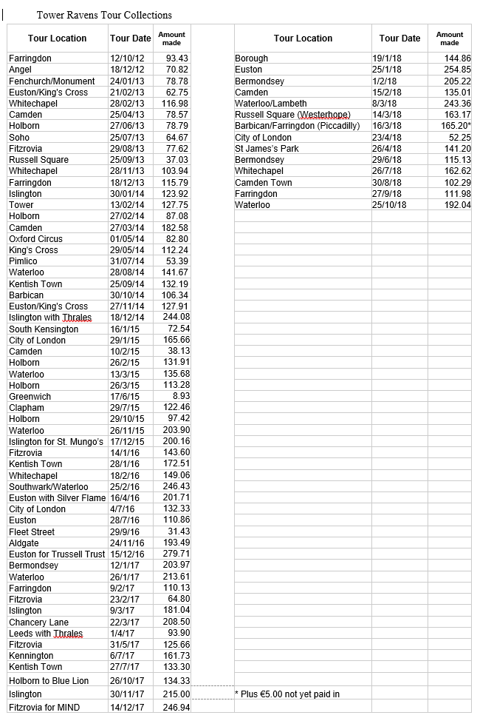

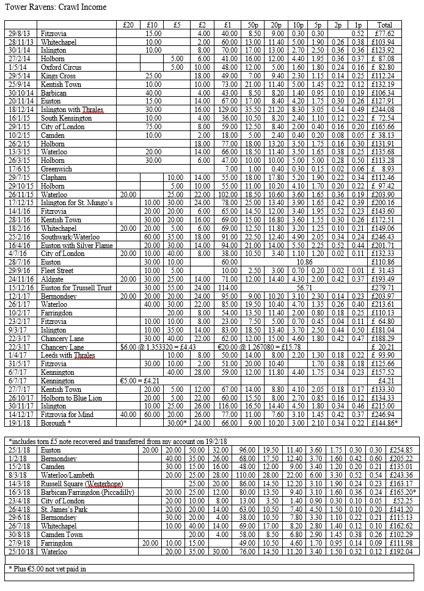

# Kit

* 2 blue feather boas
* 1 pair size 7 shoes with resin soles
* 1 petticoat
* 5 skirts varying states of repair, mostly ok though (one marked with a piece of paper saying nine...)
* 1 westerhope blouse
* 1 blue musician dress size 12
* 2 women's sashes
* 1 man sash, 1 part complete man? sash
* 7 ties
* 7 neckers, 4 dark blue, 3 brighter (2 of which starched). (some need washing as they are as they came back in i.e. rolled)
* 6 efdss pins
* 1 bag of blue and silver tinsel pieces

# Musician

I’ve effectively been in position for just under a year (having played for DERT last year), although I was formally appointed as lead musician at the EGM.

Overall it has been a good period of development for music. We did well at DERT, coming fourth overall, just four points off top place. There is plenty of room to improve, and I’ve taken on board comments from the judges and others about maintaining the energy and having sufficient volume throughout the dance – although I don’t want to compromise on the shape and colour to our dances that we’re developing. One hint for the future is that we should try to stand closer to the judges!

I’ve been trying to re-establish and build on having a specific set of tunes for each dance, to some extent choreographed to fit with the figures. I believe they’re shaping up well, but if you have any comments/questions/suggestions about them, do say. Part of my intention has been to try to develop some contrasting character to each dance through the music, in keeping with the style of the dance.

We’re lucky to have a healthy pool of dep musicians who we can call on. Patrick has been a staunch supporter of ours over the last year, but we also have welcomed Nikki back into the fold on a number of occasions, as well as Will. I want to continue to offer opportunities for each of them as equally as possible in the future as that can only strengthen us as a team.