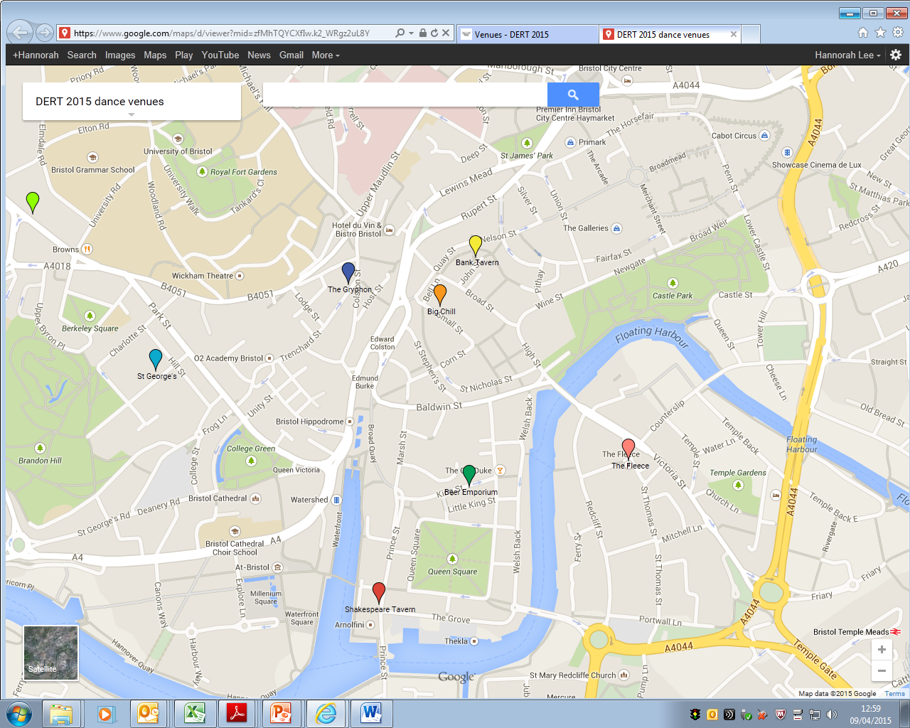**DERT Dance venues 2015 for Saturday**

**Addresses**

**Hostel:**

**Homestay , 68 Queens Road, BS1QU**

**Pubs:**

**Beer Emporium** [**15 King Street, BS1 4EF**](http://www.bing.com/maps/default.aspx?cp=51.4518~-2.594681&where1=The%20Beer%20Emporium&ss=ypid.YN1029x108119943&FORM=SNAPST)

**The Fleece, 12 St Thomas Street, BS1 6JJ**

**The Bank,** [**84 Stokes Croft, Bristol BS1 3QY**](http://www.bing.com/maps/default.aspx?cp=51.46284~-2.589663&where1=Bank&ss=ypid.YN1006x254789599&FORM=SNAPST)

**The Shakespeare, 68 Prince Street**

**Gryphon [41 Colston Street, Bristol BS1 5AP](http://www.bing.com/maps/default.aspx?cp=51.4554~-2.5978&where1=The%20Gryphon&ss=ypid.YN1029x14711427297505299476&FORM=SNAPST" \o ")**

**Big Chill 15 Small Street, BS1 1DE**

**St George's Bristol  
Great George Street  
(off Park Street)  
BS1 5RR**

**Friday evening:**

**Broad Plain Boys Club –**Clement St BS2 9ES

**Homestay**

**Map Including Temple Meads Station and Friday meeting venue, Broad Plain Boys Club**

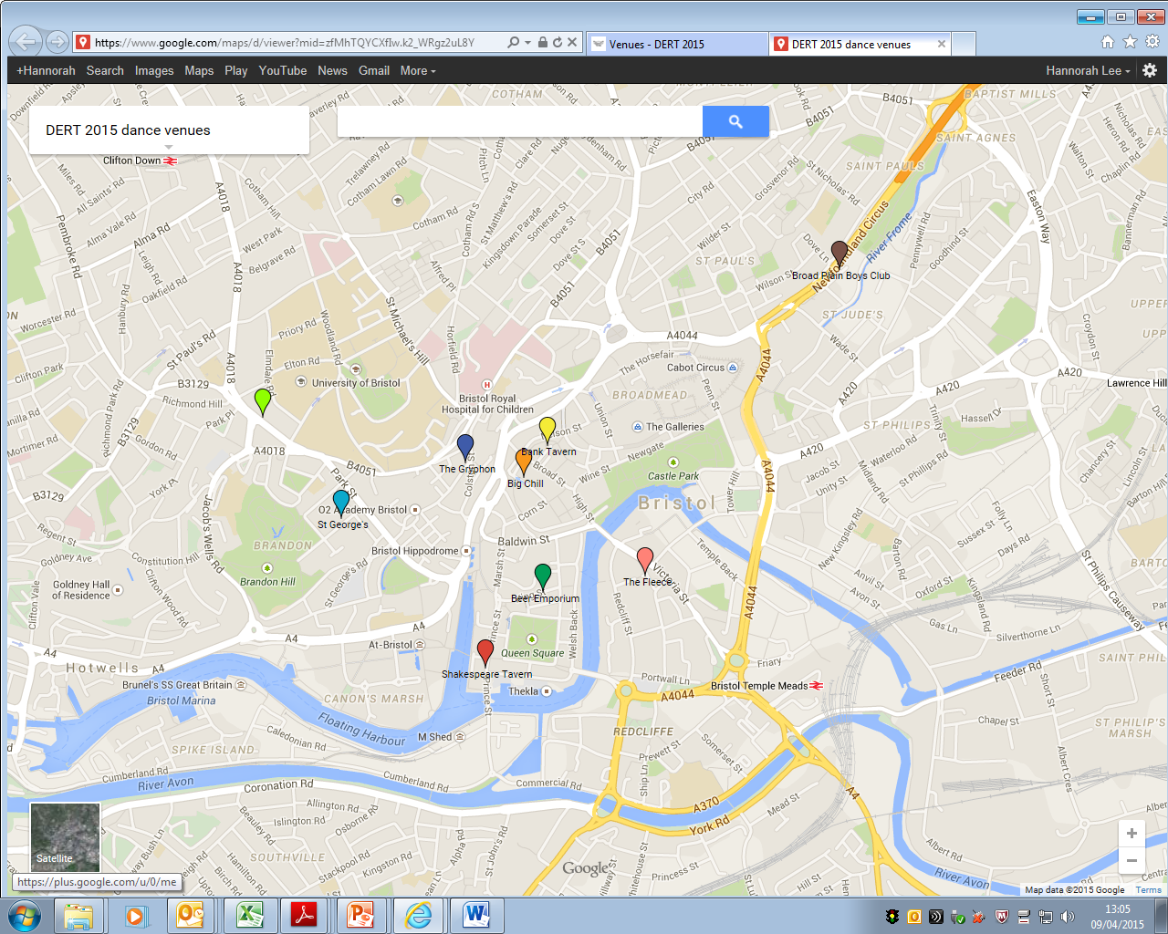

**Homestay**