Appendix A – Summary of Action Points

# Action Points

* Try Thrales shorter swords – discussed during AGM
* HN to ask Simon Vaughan/Laura Smyth about first women's rapper dance - email sent, lots of replies through, just need to take stock
* EH to organise a data discussion session – Done
* RAS to flesh out Pub Federation idea. To be tested on a crawl in future. Not done. RAS to take forward
* SC to circulate constitution (HN to save to GDrive) – Done
* HN to ask Phil Heaton for 1925 video referred to in trad marks – email sent, awaiting reply
* Incorporate Earsdon stepping into Piccadilly. Send a video and letter to the Pearsons - Stepping in, not done video and letter. BW to do
* Discuss format for DERT crawls at AGM – to be discussed
* DoD with Thrales - EW/HTD/HL/RAS to organise for May/June – not done, HTD has an idea to be discussed
* Summer Crawl on a Saturday rather than Thurs PM – not done, but had a lot of festivals
* EW to tell HN when free in May for day/evening clog practice. HN to create doodle poll - Done
* TH/EW to discuss additional Sunderland steps / them showcasing steps. Done
* MC/HL to discuss fundraising options for DART. Done
* MC to provide detail on DART via email. Done
* EH to obtain Emily's kit – FH has this.
* HN to recall neckers & pins from DERT – HL to return outstanding one.
* HN to email mailing list members that have not attended in 6 months to check whether they would like to remain on it. Done
* HN to put RAS in touch with Coral Reid regarding archiving - Done
* KR to create new YouTube account - In progress? (tidied existing - Done
* EH to review maximum expenditure on Tower Ravens account. Not done
* HN to check with Melanie regarding Whitby tickets, in case list has ended up in Spam - Done - Melanie sent info

Appendix B – Officer Reports

# Foreperson

Good year!

DERT – both did well and continued to raise profile of team with the two competitions. Particularly proud of stepping prize but also all the other positive comments and obviously music and double tommy routine. Double jubilee went down really well! I know the decision to have separate crawls was agreed to but then a bit much in reality, we need to negotiate this for the coming year.

Very packed summer but managed to attend most of what we were invited to (certainly bigger events: Warwick, Cambridge, Whitby) thanks to bigger team and committing to things! Particularly proud of double jubilee at Whitby – thanks to Martin as the determined brain-child despite my angst and everyone who’s brains worked to make it happen.

Whitby worked much better than Sidmouth for spreading out responsibility, thanks to everyone who helped!

Think proven can do excellent performances wherever we are and go above and beyond to make money.

Lots of new members who have done a great job of picking up the dancing, as well as the last batch of newer dancers doing a brilliant job at learning more positions and dances etc.

Going forward I have concerns re. the number of people in the team and my/any one person’s ability to manage practice.” Doing our best” isn’t going to be good enough longer term.

# Treasurer

**Treasurer’s Report 31.10.2019**

**Bank Balances**

|  |  |  |  |  |  |  |  |
| --- | --- | --- | --- | --- | --- | --- | --- |
| 31/10/12 | 18/11/13 | 31/10/14 | 31/10/15 | 31/10/16 | 31/10/17 | 31/10/18 | 31/10/19 |
| £0.73 | £309.24 | £659.51 | £1352.62 | £1360.50 | £776.43 | £1229.86 | £1,592.63 |

**Outstanding payments in:** £138.15 from Euston crawl and £31.46 from Forest Hill crawl

**Payments out due:**  None

**Income/Expenditure summary 2013-31/10/19**

|  |  |  |  |  |  |  |
| --- | --- | --- | --- | --- | --- | --- |
| **Income** | **2013** | **2015** | **2016** | **2017** | **2018** | **2019** |
| subs | £1472.00 | £1977.85 | £1722.90 | £2108.00 | £1922.00 | £2276.00 |
| tour collection | £666.01 | £1258.00 | £1591.99 | £1969.84 | £2790.45 | £2121.68 |
| kit purchase | £248.00 | £50.00 | £    70.50 |  | £467.50 | £400* |
| DERT accommodation | £196.00 |  | £  435.00 |  | £86.21 | £697.25 (train) |
| Pizza Express |  |  | £  220.72 |  |  |  |
| other income | £15.12 |  | £    60.00 | £65.65 | £27.00 |  |
| Leeds travel and hotel |  |  |  | £723.40 |  |  |
| Performance fee |  |  |  |  | £50.00 | £875 |
| Other travel |  |  |  |  | £77.49 | ** |
| Guest tickets |  |  |  |  | £237.50 | £135 |
| **total** | **£2597.13** | **£3285.85** | **£4101.11** | **£4866.89** | **£5658.15** | **£6698.48** |
|  |  |  |  |  |  |  |
| **Expenditure** |  |  |  |  |  |  |
| hall hire | £1410.00 | £1710.00 | £1560.00 | £1656.00 | £1890.00 | £1740.00 |
| swords | £247.00 | £224.00 |  |  |  | £292.95 |
| kit purchase | £292.98 | £35.38 | £  198.55 |  | £870.73 | £442.08 |
| DERT registration | £244.00 | £255.00 | £  420.00 | £400.00 | £295.00 | £310.00 |
| DERT accommodation |  |  | £  950.00 | £852.00 | £748.60 | £1514.70 |
| Other accommodation |  |  |  | £150.00 |  |  |
| Leeds travel and hotel |  |  |  | £723.40 |  |  |
| admin | £74.00 | £20.77 | £    13.00 |  | £61.83 |  |
| chocolate eggs | £20.64 | £9.00 |  |  |  |  |
| drinks |  | £109.55 | £    64.60 | £33.40 | £28.70 | £76.16 |
| Open Morris |  | £35.00 | £    35.00 | £35.00 | £35.00 | £35.00 |
| sundries |  | £62.75 | £    23.48 | £163.00 | £178.72 | £195.08 |
| Other travel |  | £190.00 | £  196.70 | £968.45 | £763.44 | £835.90* |
| Charity donations |  |  | £  200.00 | £329.71 | £250.00 | £200.00 |
| Oyster cards |  |  | £    50.00 |  |  |  |
| Pizza Express |  |  | £  275.26 |  |  |  |
| Guest tickets |  |  |  |  | £237.50 | £135.00 |
| Sidmouth shortfall (written off) |  |  |  |  | £15.00 |  |
| Whitby Jellyfish |  |  |  |  |  | £269.04 |
| Performance |  |  |  |  |  | £200.00 |
| **total** | **£2288.62** | **£2851.45** | **£3806.59** | **£5370.96** | **£5374.52** | **£6335.71** |

*rounded - I confused this figure slightly by lumping kit reimbursement in with Whitby expenses

**some for Whitby, see comment above

**Comments**

Current monthly income from subs from October 2019 is £216.

Current monthly hall hire remains at £120/£150. It has been agreed this will increase to £130/£162.50 in January 2020. This year includes an extra £180.00 for 2 sessions at Abbey CC.

Other annual expenses include Open Morris £35.00, DERT registration, travel/accommodation, admin (e.g. website hosting, leaflets and business cards) and sundries.

We received £875 for performances - by far the most we’ve ever been paid. £200 of this went to Nozzy for their help with the St Patrick’s Day performance.

Average crawl income November 2018 - October 2019 was £140.54, slightly lower than last year. Includes £191 for Centrepoint, not including collections at festivals and the Forest Hill Sunday crawl.

|  |  |
| --- | --- |
| Year (November to October) | Average Crawl Income |
| 2013/14 | £74.01 |
| 2015/16 | £114.35 |
| 2015/16 | £162.20 |
| 2016/17 | £161.86 |
| 2017/18 | £164.14 |
| 2018/19 | £140.54 |

We donated £200 to Centrepoint on 22/01/19.

We paid all accommodation costs for DERT this year and therefore did not subsidise travel to Newcastle.

Financial decisions at last year’s AGM:

* Subs to remain at £12 or £8 for current students/unwaged
* Christmas collection to be donated to charity (Centrepoint)
* Reimbursement/subsidy for travel expenses should be equal to half the fare paid
* Accommodation subsidy as agreed whenever appropriate

**Other assets**

* 3 sets of rapper swords and sword bags (Hannah and Becky)
* 4 pewter tankards (Katherine, Laura W, Jo, Hannah)
* Limited spare kit (Hannah)
* 1 roll each of black and blue skirt fabric (Sue)
* Assorted fabric, haberdashery and diamante applicator (Sue)
* Bugle and stuffed raven (Sue)
* Westerhope ties and EFDSS badges
* Tommy outfit (Hannah)

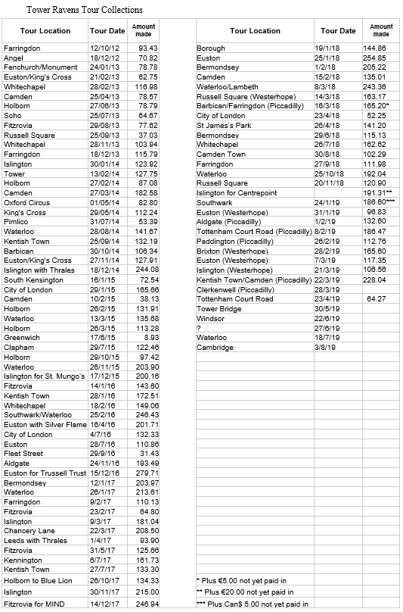

# Kit

* Tommy Outfit (as worn by Paul)
* Size 7 rapper shoes, worn
* Size 3 (labelled as 4) rapper shoes, new
* 2 old style westerhope shirts
* Union jack safety pants
* 1 paper fan
* 4 ties
* 2 skirts
* 1 complete man sash, 1 man sash no tails, 1 man sash waistband template
* 6 neckers (HL has one as well)
* 6 EFDSS pins
* 1 old style hoody (L)
* 1 musician dress
* Feather boa
* Tinsel
* Raven topped fascinator with broken wing
* Jellyfish umbrellas
* The kitty purse
* 2 skull hair bobbles
* 1 top hat
* TR banner
* The skanky sash
* 1 waistband of a sash
* Stash:
  + Trial t-shirts, no logo
  + 1 small hoody
  + 3 L ladies fit T
  + 1 L ladies fit T with armpit hole
  + 2 L unisex T
  + 1 XL ladies fit T
  + 1 S ladies T
* 1 man/preggers sash
* Sheep shaped baking tin

# Musician

It has been an excellent year for the team, and I’m pleased with the role that the music has played in the continued development of our performance. We’ve worked hard to continue to intertwine the music with the movement of the dance, and the feedback that we’re getting at pretty much every booking is that this is paying dividends. It helps us as a team to stand out from the crowd when we’re able to put on a single performance together, rather than the musicians just playing any old jig to accompany the dances.

We’ve reached the stage where all of our dances, right up to the new clog, have their own specific routines for the music. This helps to give each dance more of a different feel, but it also brings a new level of excitement to each dance that was perhaps lacking a little with Jubilee and Westerhope compared to Piccadilly. The epitome of that started with our showcase Jubilees at DERT, which I think look excellent, and of course our fabulous performance with the final Jubilee at Whitby, which I’m super-proud of everyone for.

Earlier in the year we recruited Will Allen and Ali Barnes as deps. Unfortunately, Ali’s circumstances mean that she hasn’t been able to be part of the team in the way she hoped, but I’d like to thank her for the bookings she came to with the team. But I want to extend particular thanks to Will, whom we invited to join us at DERT, but has since shown total commitment, coming to as many crawls and bookings as possible, and immersing himself in the group – as he aptly demonstrated on Saturday, saying, “I’ve never been flirted on by so many people at one time before. It’s too much for a young man to take!”. I’d also like to thank Patrick who continues to stand in on occasion when Will and I can’t make it, and it was fun having both him and Will together at Whitby. Lots of sound!

So with Will’s commitment the music has evolved into being a standard fiddle-melodeon duo. I think it’s sounding great, will continue to improve and I think everyone enjoys dancing to it. We’re continuing to refine and develop the sets, and I propose keeping the tunes we’ve got for now and maybe consider a refresh after DERT.

In general, we would benefit from having one more backup musician. Following discussions with Becky this person would should be a dancer and would ideally be a fiddle player for volume and clarity of sound. If other musicians are interested in playing, we’re happy to discuss. However, we’re not going to try to recruit someone specially for the time being.

DERT

I’d propose keeping it as is with me and Will for DERT – and leave a decision about the traditional dance subject to a discussion between the leader for the traditional dance and me. Previously we’ve favoured having just a single musician as per the records.