T-SHIRT



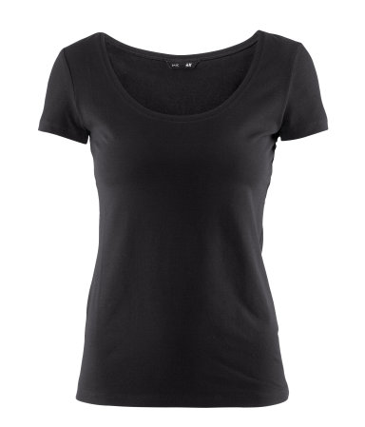

DESCRIPTION

Short-sleeved, figure-fit top in soft, stretch jersey

DETAILS

5% elastane, 95% cotton. Machine wash at 40˚

Art.No. 83-8980

Buy from H+M £3.99

Divided Basics range (with round neckline, not V-shaped)

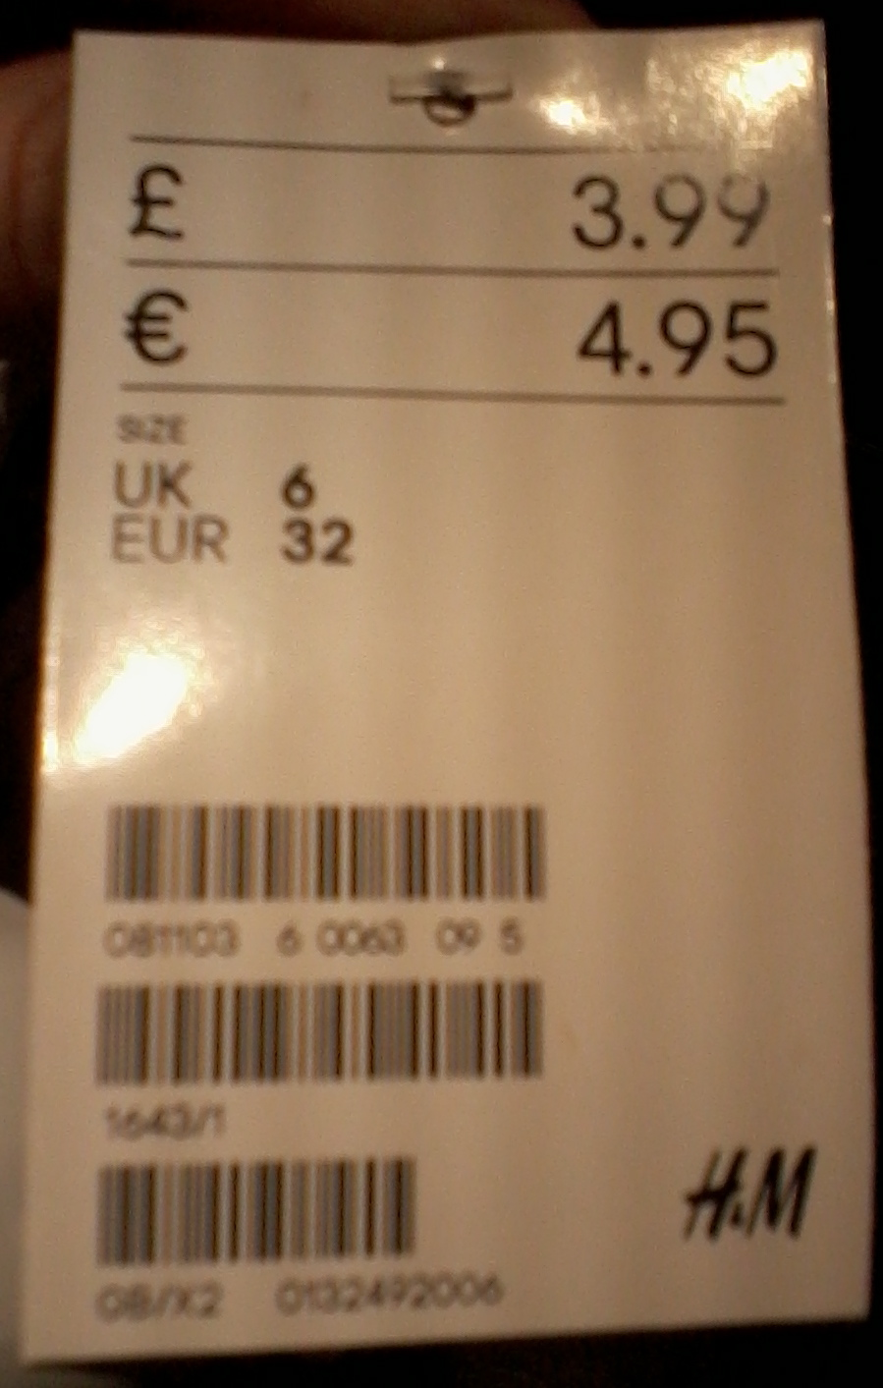

NB The stock number on the garment label may not correspond with that on the H+M website.

**TIGHTS**

Plain black

Buy your own. 40 or 60 denier

**PARADE SHOES**

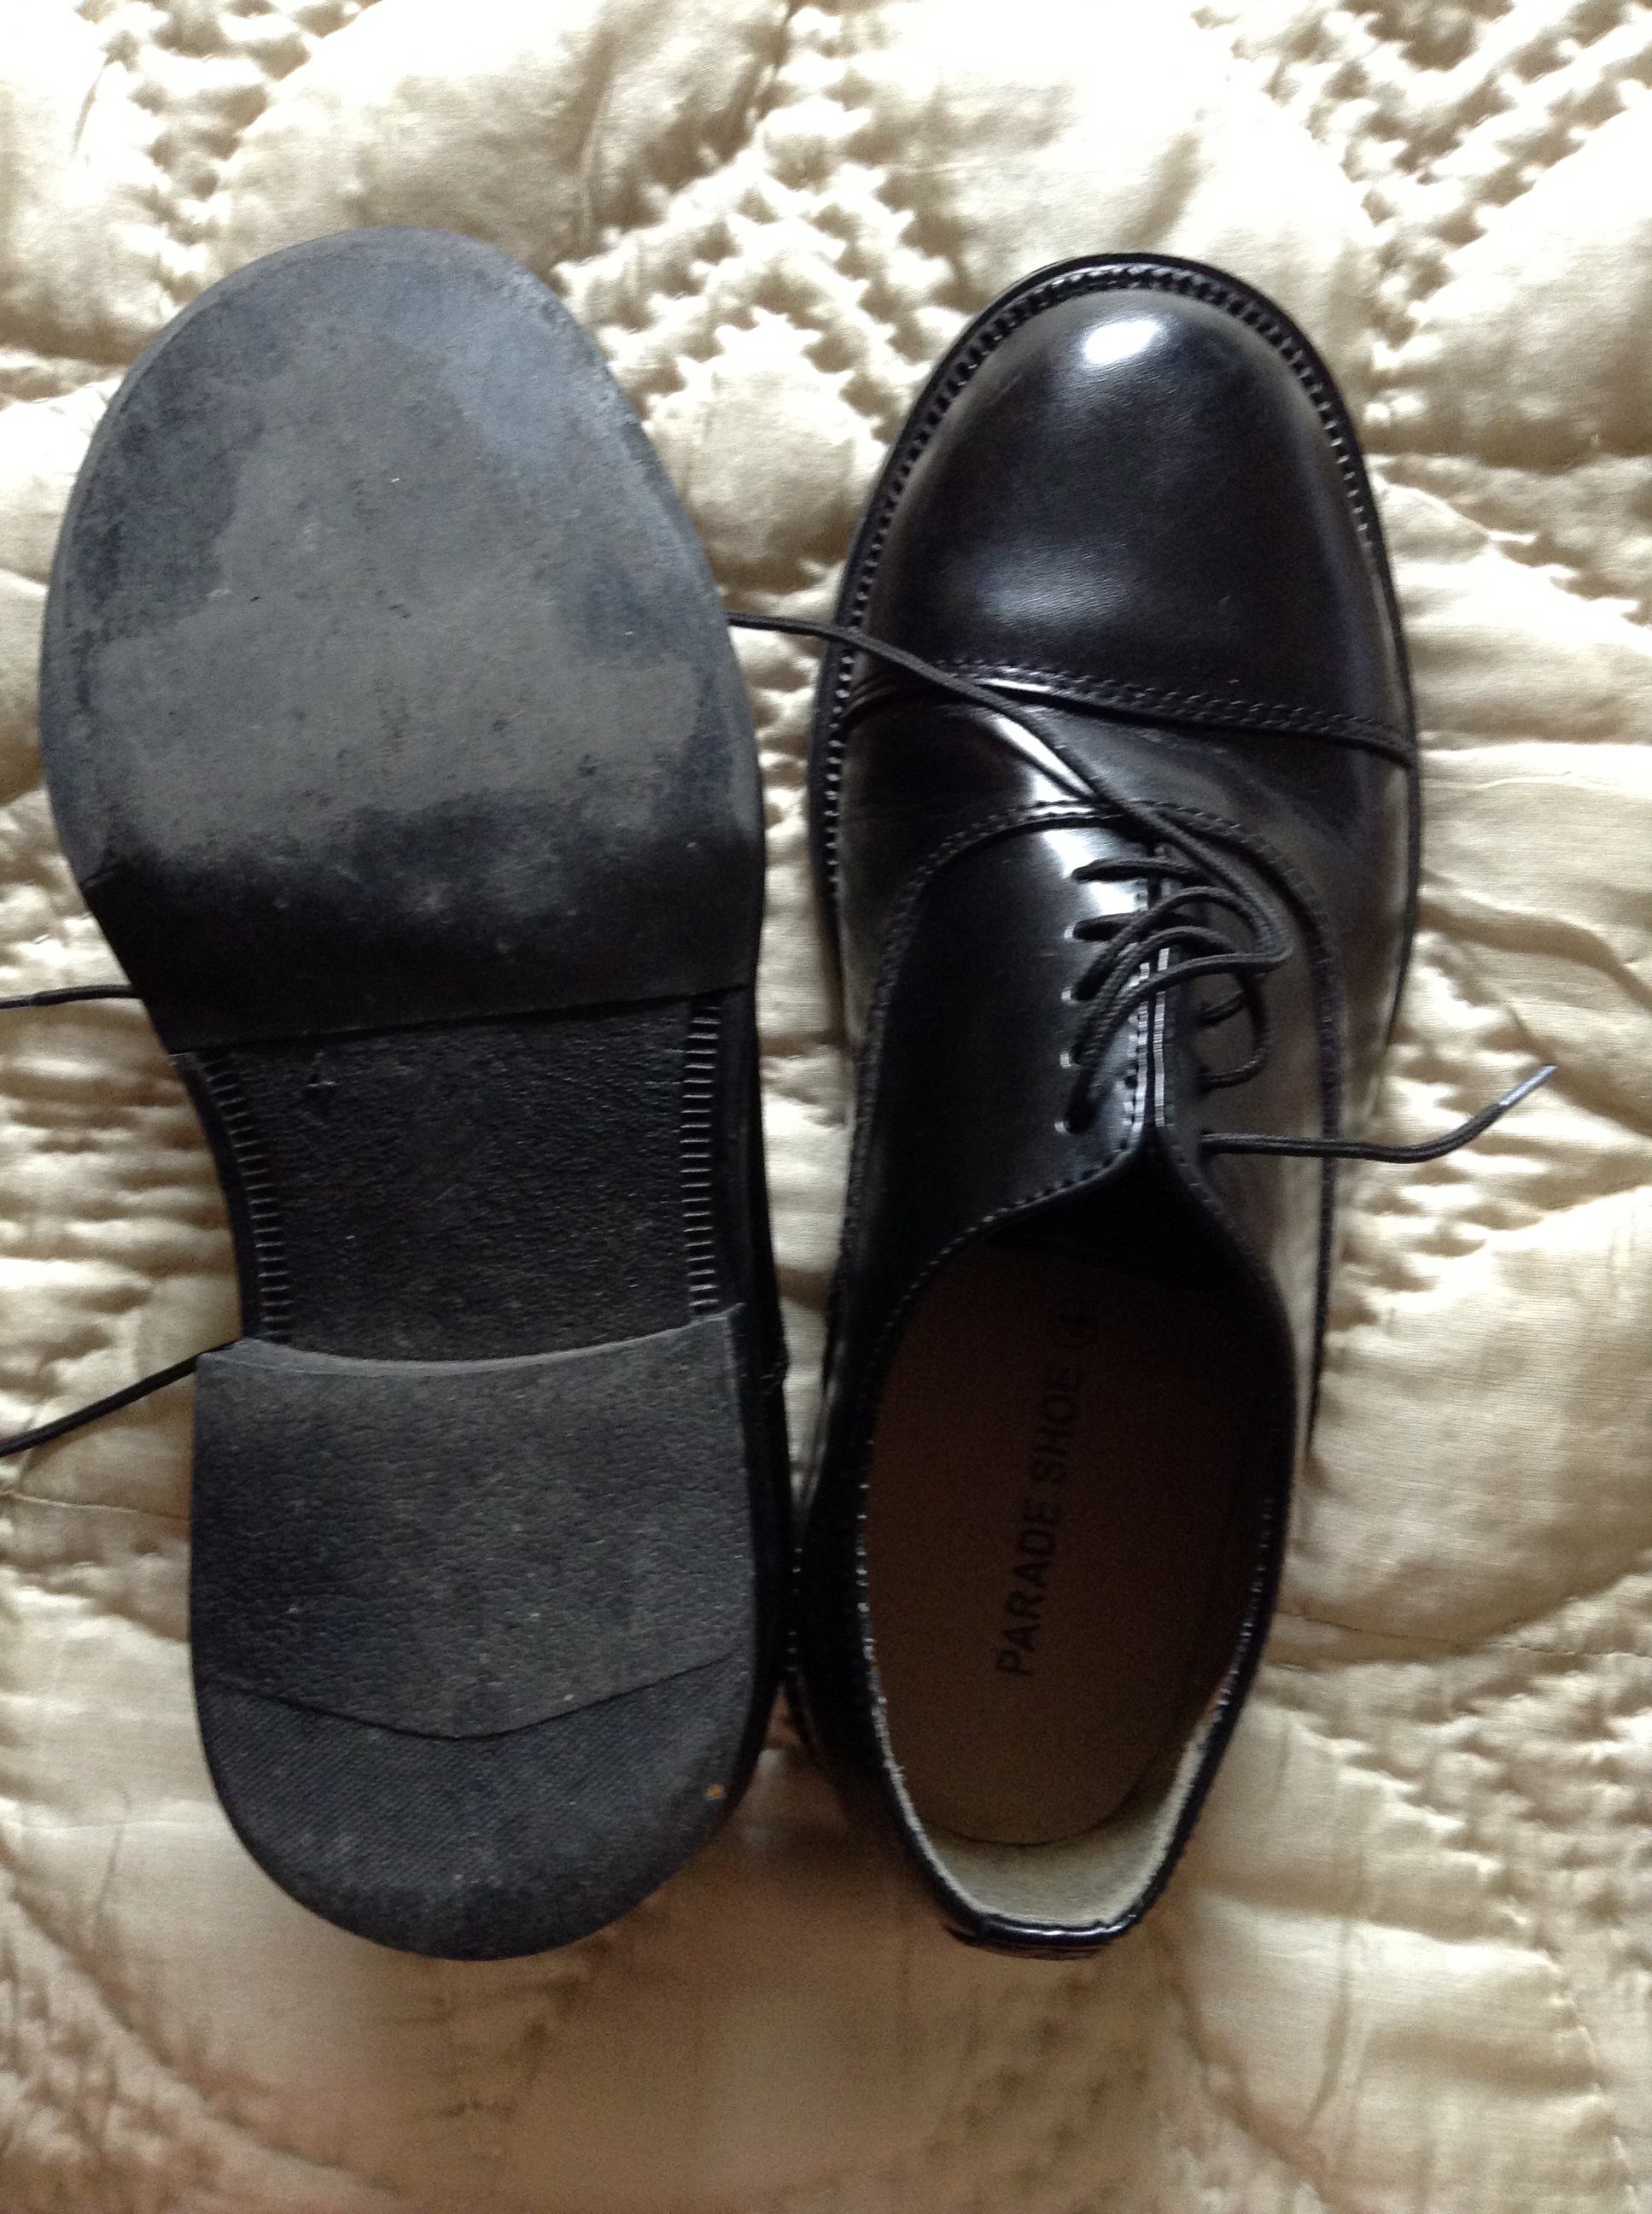

Available by mail order from:

<http://cadetsuk.com/contents/en-us/d231_parade_shoes__aircadets.html#p1452>

You need the ones labelled "Parade shoes atc cadets / 0610370704219 / Size 3 to 15"

NB The smaller sizes come up rather large; the larger sizes rather small! We advise you to try on a pair of one of the Ravens in your size, to prevent having to exchange them.

They need to have additional resin soles.

Recommended polish: Kiwi Parade Gloss, black