**BRIGHTON MORRIS DAY OF DANCE**

**SATURDAY 14TH MAY 2016 #BrightonDoD**

|  |  |  |  |  |  |  |  |
| --- | --- | --- | --- | --- | --- | --- | --- |
|  | **11.00 – 11.50** | **12.00 – 12.45** | **12.50 – 13.40** | **13.40 – 14.20** | **14.20 - 15.00** | **15.00 – 15.45** | **16.00 – 17.00** |
| **Pavilion Gardens Cafe** | **All sides will perform at this iconic cafe** |  |  | **L** |  |  |  |
| **3 Jolly Butchers** |  | **Brighton**  **Steampunk**  **Marlings** | **Pump House Clog**  **Armaleggan**  **Customs & Exiles** | **U** | **Tower Ravens**  **Beltane**  **Black swan** | **Cuckoos Nest**  **Blackheath**  **Ditchling** |  |
| **Brighton Tavern** |  | **Cuckoos Nest**  **Tower Ravens**  **Customs & Exiles** | **Brighton**  **Blackheath**  **Beltane** | **N** | **Marlings**  **Armaleggan**  **Ditchling** | **Steampunk**  **Pumphouse Clog**  **Black swan** |  |
| **Pump House** |  | **Beltane**  **Pump House Clog**  **Ditchling** | **Cuckoos Nest**  **Marlings**  **Black Swan Morris** | **C** | **Steampunk**  **Custom & Exiles**  **Blackheath** | **Brighton**  **Tower Ravens**  **Armaleggan** |  |
| **The Basketmakers Arms/ The Eagle** |  | **Armaleggan**  **Blackheath**  **Black Swan** | **Tower Ravens**  **Steampunk**  **Ditchling** | **H** | **Brighton**  **Cuckoos Nest**  **Pumphouse Clog** | **Marlings**  **Custom & Exiles**  **Beltane** |  |
| **Brighton Fishing Museum** |  |  |  |  |  |  | **The Grand Finale with a show dance from each of the sides** |

**Dance order for Pavilion Cafe** Brighton - Steampunk - Marlings - Tower Ravens - black swan Morris - Customs & Exiles – Ditchling - Beltane - Pump House Clog – Armaleggan – Blackheath - Cuckoos Nest

**Dance order for Fishing Museum** Cuckoos Nest - blackheath – Armaleggan – Pump House Clog – Beltane – Ditchling - Customs & Exiles – Tower Ravens – black swan - marlings – Steampunk - Brighton

Any problems ring Jaz 07902184482 or Chris 07739900851

Brighton Morris' Day of Dance 2016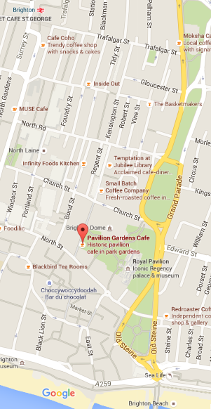

**The Lord Nelson**

Friday 13th May (evening)

Brighton Morris will be drinking at The Sir Charles Napier (50 Southover Street, BN2 9UE) - all welcome!

**Brighton Tavern**

**Basketmakers and Eagle**

Saturday 14th May

10.30am-5pm Day of Dance (see above)

6pm- Drinking, singing & general merriment at The Lord Nelson (36 Trafalgar St, BN1 4ED)

**3 Jolly Butchers**

**Pavilion Gardens cafe**

**Brighton Fishing Museum**

**Pump House**