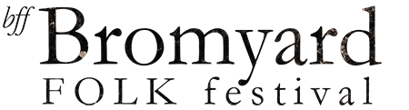

Bromyard Folk Festival 6th- 9th September 2018

Morris/Partner Ticket Receipt

Thank you for joining us at Bromyard Folk Festival 2018, we are looking forward to seeing you. Your performer or partner wristband is collectable from the Stewards office on the main festival site (located to the right of the main entrance). This receipt will enable you access to the collection desk, the festival site opens at 4pm on Thursday 6th September. Please note wristbands are only available for those named on your team ticket list and are non-transferable. Directions to the festival site are available on the Bromyard folk festival website.

Name:

Team:

Once again, we thank you for joining us, and look forward to seeing you in Bromyard.

Any queries, please get in contact.

Ross Grant

Festival Director

raa.grant@gmail.com